# Temă PSI

**Cap 4.4. Proiectarea bazei de date**

Baza de date: PSI

Tabelele bazei de date sunt:

* Utilizatori
* IstoricMedical
* Pacienti
* Programari
* Tratamente
* Furnizori
* Materiale
* LucrariDentare
* Facturi

Tabelul Utilizatori

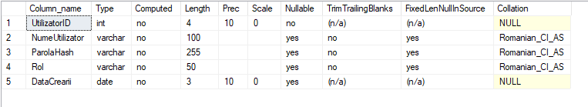

CREATE TABLE Utilizatori (

UtilizatorID INT PRIMARY KEY IDENTITY(1,1),

NumeUtilizator VARCHAR(100),

ParolaHash VARCHAR(255),

Rol VARCHAR(50),

DataCrearii DATE

);

Tabelul IstoricMedical:

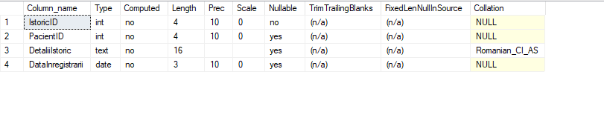

CREATE TABLE IstoricMedical (

IstoricID INT PRIMARY KEY IDENTITY(1,1),

PacientID INT,

DetaliiIstoric TEXT,

DataInregistrarii DATE,

FOREIGN KEY (PacientID) REFERENCES Pacienti(PacientID)

);

Tabelul Pacienti:

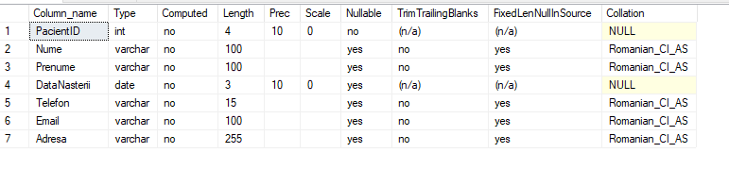

CREATE TABLE Pacienti (

PacientID INT PRIMARY KEY IDENTITY(1,1),

Nume VARCHAR(100),

Prenume VARCHAR(100),

DataNasterii DATE,

Telefon VARCHAR(15),

Email VARCHAR(100),

Adresa VARCHAR(255)

);

Tabelul Programari:

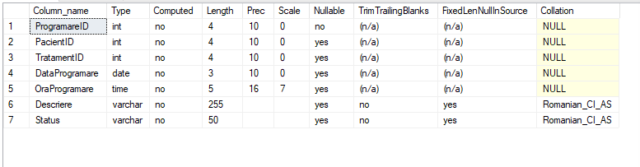

CREATE TABLE Programari (

ProgramareID INT PRIMARY KEY IDENTITY(1,1),

PacientID INT,

TratamentID INT,

DataProgramare DATE,

OraProgramare TIME,

Descriere VARCHAR(255),

Status VARCHAR(50),

FOREIGN KEY (PacientID) REFERENCES Pacienti(PacientID),

FOREIGN KEY (TratamentID) REFERENCES Tratamente(TratamentID)

);

Tabelul Tratamente:

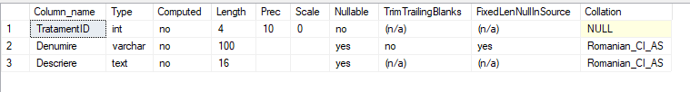

CREATE TABLE Tratamente (

TratamentID INT PRIMARY KEY IDENTITY(1,1),

Denumire VARCHAR(100),

Descriere TEXT

);

Tabelul Furnizori:

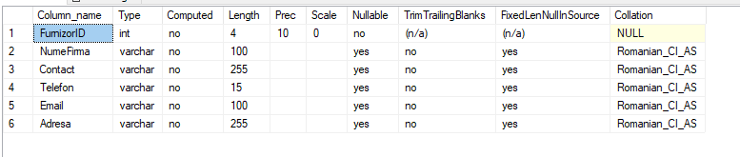

CREATE TABLE Furnizori (

FurnizorID INT PRIMARY KEY IDENTITY(1,1),

NumeFirma VARCHAR(100),

Contact VARCHAR(255),

Telefon VARCHAR(15),

Email VARCHAR(100),

Adresa VARCHAR(255)

);

Tabelul Materiale:

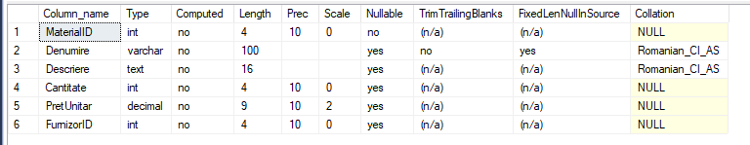

CREATE TABLE Materiale (

MaterialID INT PRIMARY KEY IDENTITY(1,1),

Denumire VARCHAR(100),

Descriere TEXT,

Cantitate INT,

PretUnitar DECIMAL(10, 2),

FurnizorID INT,

FOREIGN KEY (FurnizorID) REFERENCES Furnizori(FurnizorID)

);

Tabelul LucrariDentare:

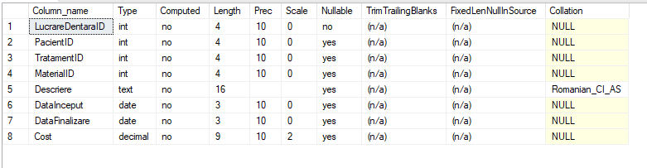

CREATE TABLE LucrariDentare (

LucrareDentaraID INT PRIMARY KEY IDENTITY(1,1),

PacientID INT,

TratamentID INT,

MaterialID INT,

Descriere TEXT,

DataInceput DATE,

DataFinalizare DATE,

Cost DECIMAL(10, 2),

FOREIGN KEY (PacientID) REFERENCES Pacienti(PacientID),

FOREIGN KEY (TratamentID) REFERENCES Tratamente(TratamentID),

FOREIGN KEY (MaterialID) REFERENCES Materiale(MaterialID)

);

Tabelul Facturi:

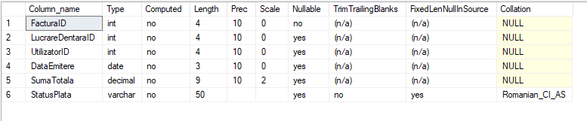

CREATE TABLE Facturi (

FacturaID INT PRIMARY KEY IDENTITY(1,1),

LucrareDentaraID INT,

UtilizatorID INT,

DataEmitere DATE,

SumaTotala DECIMAL(10, 2),

StatusPlata VARCHAR(50),

FOREIGN KEY (LucrareDentaraID) REFERENCES LucrariDentare(LucrareDentaraID),

);

Relatiile/Legaturile dintre tabele:

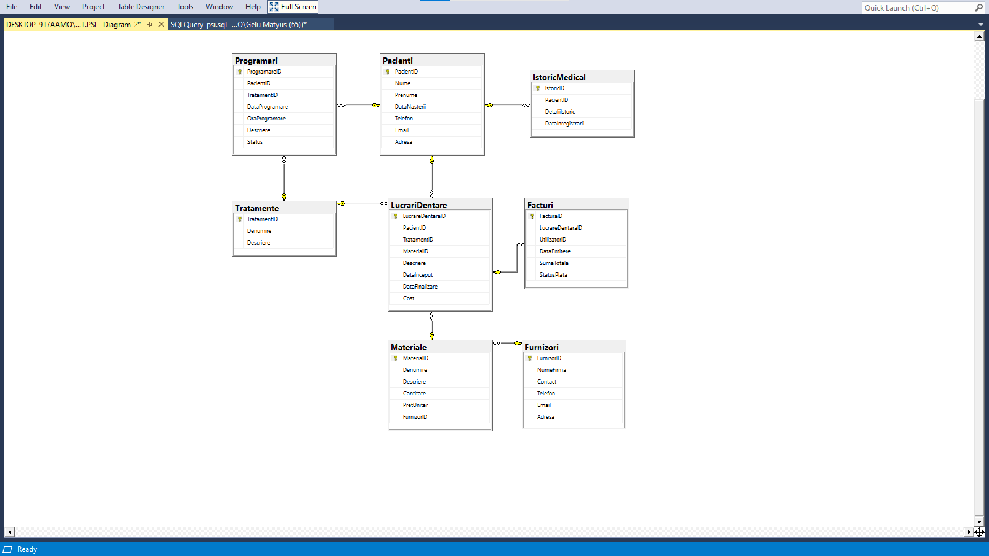

Securitatea bazei de date:

Roluri:

|  |  |  |  |  |
| --- | --- | --- | --- | --- |
| **Tabel** | **Câmp (Tip, lungime)** | **Utilizator** | **Grup** | **Drepturi** |
| Utilizatori | * | admin | Administrators | Full Rights |
| * | user1 | Users | Read only |
| Programari | * | admin | Administrators | Full Rights |
| * | user1 | Users | Read only |
| Tratamente | * | admin | Administrators | Full Rights |
| * | user1 | Users | Read only |
| Materiale | * | admin | Administrators | Full Rights |
| * | user1 | Users | Read only |
| Facturi | * | admin | Administrators | Full Rights |
| * | user1 | Users | Read only |
| Pacienti | * | admin | Administrators | Full Rights |
| * | user1 | Users | Read only |
| IstoricMedical | * | admin | Administrators | Full Rights |
| * | user1 | Users | Read only |
| LucrariDentare | * | admin | Administrators | Full Rights |
| * | user1 | Users | Read only |
| Furnizori | * | admin | Administrators | Full Rights |
| * | user1 | Users | Read only |

Criptare:

|  |  |  |  |
| --- | --- | --- | --- |
| **Tabel** | **Câmp** | **Tip (lungime)** | **Criptare** |
| Utilizatori | Parola | Text(50) | MD5 |
| Medic | Parola | Text(50) | MD5 |

